### **AI-powered Nutrition Analyzer for Fitness Enthusiasts**

Team Leader **:** E.Santhiya

Team Member : P.Shalini, S.Sneha, M.Sridharan.

Faculty Mentor Name : Sweetline Sonia M

**Apply Image Data Generator Functionality To Trainset And Test set**

Let us apply Image Data Generator functionality to Trainset and Test set by using the following code

For Training set using flow from directory function.

This function will return batches of images from the subdirectories 'apples', 'banana',

'orange', 'pineapple', 'watermelon' together with labels 0 to 4{'apples': 0, 'banana': 1,

'orange': 2, 'pineapple': 3, 'watermelon': 4}

**Arguments:**

* directory: Directory where the data is located. If labels are "inferred", it should contain subdirectories, each containing images for a class. Otherwise, the directory structure is ignored.
* Batch size: Size of the batches of data. Default: 32.
* Target size: Size to resize images after they are read from disk.
* Class mode:
  + ‘int': means that the labels are encoded as integers (e.g. for sparse categorical crossentropy loss).
  + 'categorical' means that the labels are encoded as a categorical vector (e.g. for categorical crossentropy loss).
  + 'binary' means that the labels (there can be only 2) are encoded as float32 scalars with values 0 or 1 (e.g. for binary crossentropy). - None (no labels).

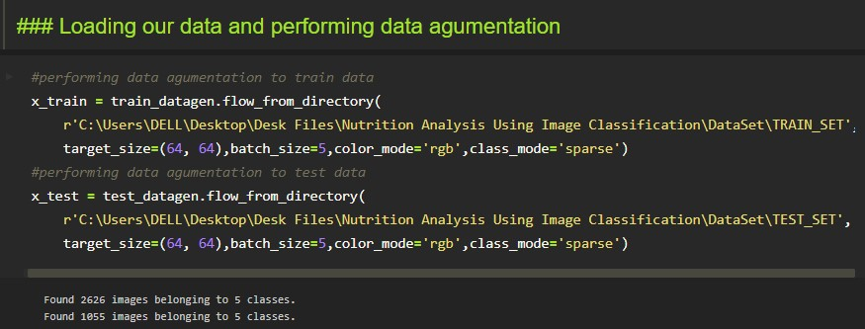

We notice that 2626 images are belonging to 5 classes for training and 1055 images belong to 5 classes for testing purposes.

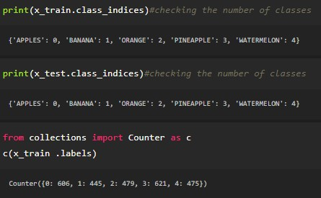

Here we are checking the number of classes in train and test data and counting the number of images in each class of train set data by using the counter function.